1. 
2. Sometimes, we need some thread to wait until some condition becomes true. 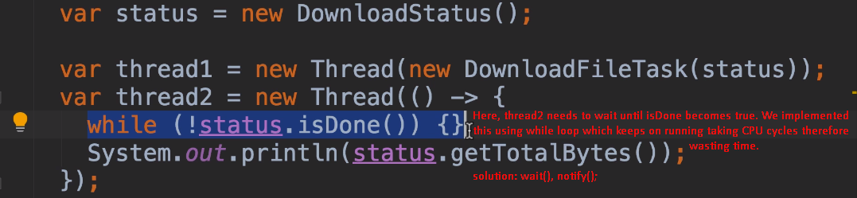
3. 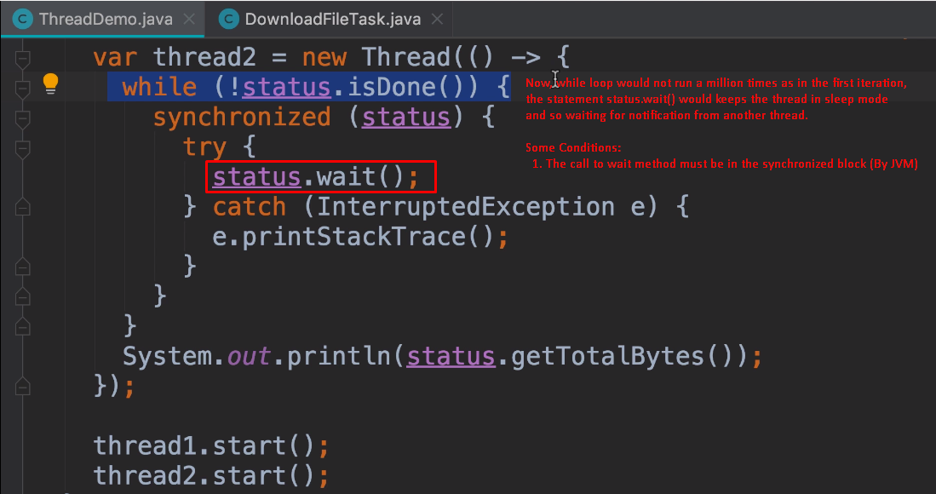
4. 